PowerShell Working with JSON

Part 1: Running the Lab
Walk through each step in order, running the corresponding script section and capturing the listed screenshot before moving on. Run everything from the project root folder so relative paths like .\data\students.xml resolve correctly.

Step 01 — Create the Project Folder
Create a dedicated folder for this lab. This keeps scripts, JSON data, CSV output, and screenshots organized.
mkdir PowerShell-Working-with-JSON
cd PowerShell-Working-with-JSON
mkdir scripts, data, screenshots, docs
Open the folder in File Explorer or VS Code (code .) and confirm you see scripts, data, screenshots, and docs subfolders.
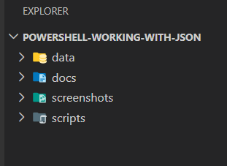
File Explorer showing this folder structure.

Step 02 — Create the Sample JSON File
In VS Code, create data\students.json and paste in the fictional sample data (John Micheal, Jon Mike, Sara Ahmed). Save it.
[
{ "id": 1, "name": "John Micheal", "age": 20, "grade": "A" },
{ "id": 2, "name": "Jon Mike", "age": 21, "grade": "B" },
{ "id": 3, "name": "Sara Ahmed", "age": 19, "grade": "A" }
]
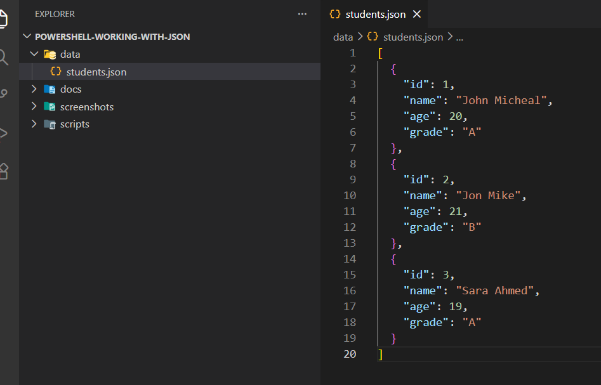students.json open in VS Code (or visible in File Explorer).

Step 03 — Load the JSON in PowerShell
Create scripts\Task1-Query-JSON.ps1 and add the loading portion first to confirm it works. Run it from the project root.
$jsonData = Get-Content -Path ".\data\students.json" | ConvertFrom-Json
$jsonData
Expected: no errors, and PowerShell prints the parsed JSON objects.
# Task 1: Load and query JSON data
$jsonPath = ".\data\students.json"

# Load JSON data
$jsonData = Get-Content -Path $jsonPath | ConvertFrom-Json

# Display parsed JSON objects
$jsonData

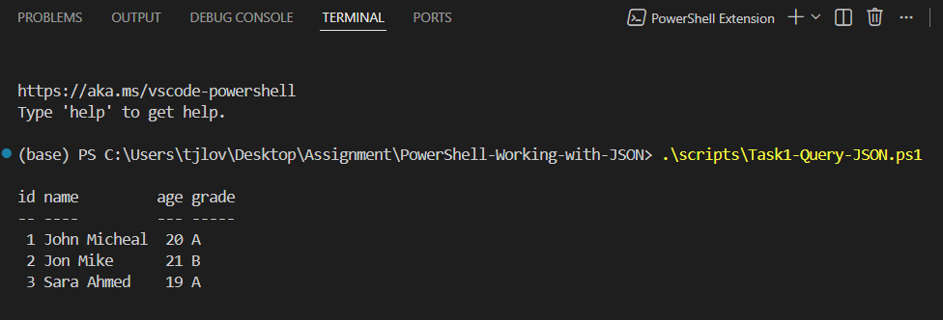

Terminal showing the JSON loaded cleanly.

Step 04 — Query Student Names and Ages
Add the query loop to the Task1 script and rerun it.
Name: John Micheal, Age: 20
Name: Jon Mike, Age: 21
Name: Sara Ahmed, Age: 19
This is the expected console output.
# Display names and ages of all students
foreach ($student in $jsonData) {
$name = $student.name
$age = $student.age
Write-Host "Name: $name, Age: $age"
}

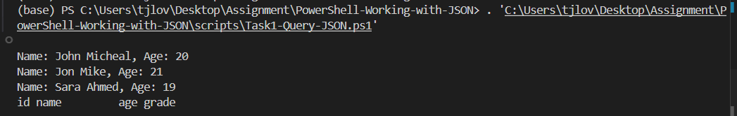
Terminal output listing student names and ages.

Step 05 — Find a Student Grade by ID
Still in Task1, add the ID lookup block ($studentId = 1). Run and confirm the result.
Student with ID 1 has a grade of A
Expected console output.
# Find and display the grade of a specific student by ID
$studentId = 1

$student = $jsonData | Where-Object { $_.id -eq $studentId }

if ($student) {
$grade = $student.grade
Write-Host "Student with ID $studentId has a grade of $grade"
} else {
Write-Host "Student with ID $studentId was not found."
}

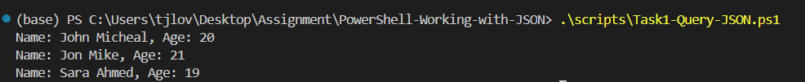

Terminal output showing a grade for the selected student ID.

Step 06 — Add a New Student Entry
Create scripts\Task2-Modify-JSON.ps1 and paste the "Add a new student entry" block, using a unique id (4) and a fictional name such as Mariam Ali. Run it.
$newStudent = @{
"id" = 4
"name" = "Mariam Ali"
"age" = 22
"grade" = "C"
}
$jsonData += $newStudent
At this point Mariam Ali (ID 4) exists only in memory — it is not yet saved to disk. That happens in Step 09.
Script or terminal output showing a new student entry was added.

Step 07 — Update an Existing Student's Age
Add the "Update age" block to the same Task2 script — update Jon Mike (ID 2) to age 23. Run it.
Student with ID 2 updated to age 23.
Expected console output (add a Write-Host confirmation line if not already in your script).
# Update the age of an existing student
$studentIdToUpdate = 2
$newAge = 23

$studentToUpdate = $jsonData | Where-Object { $_.id -eq $studentIdToUpdate }

if ($studentToUpdate) {
$studentToUpdate.age = $newAge
Write-Host "Student with ID $studentIdToUpdate updated to age $newAge."
} else {
Write-Host "Student with ID $studentIdToUpdate was not found."
}

Terminal output showing the age was updated successfully.

Step 08 — Remove a Student Entry
Add the "Remove a student entry" block — remove the newly added Mariam Ali (ID 4), demonstrating add-then-remove. Run it.
Student with ID 4 removed.
Expected console output (add a Write-Host confirmation line if not already in your script).
# Remove a student entry by ID
$studentIdToRemove = 4

$studentExists = $jsonData | Where-Object { $_.id -eq $studentIdToRemove }

if ($studentExists) {
$jsonData = $jsonData | Where-Object { $_.id -ne $studentIdToRemove }
Write-Host "Student with ID $studentIdToRemove removed."
} else {
Write-Host "Student with ID $studentIdToRemove was not found."
}
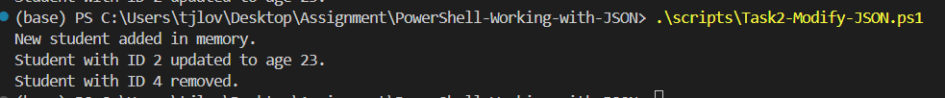

Terminal output showing the selected student was removed.

Step 09 — Save the Modified JSON File
Add the final ConvertTo-Json | Set-Content line and run the full Task2 script end-to-end (all four operations in sequence).
$jsonData | ConvertTo-Json | Set-Content -Path ".\data\students.json"
Open students.json in VS Code afterward and confirm: Jon Mike's age is 23, Mariam Ali is not present, and John Micheal and Sara Ahmed are unchanged.
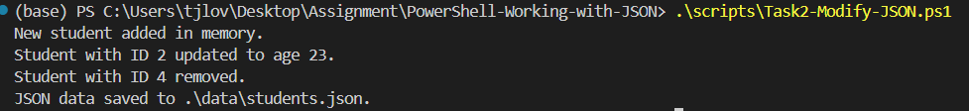

VS Code or File Explorer showing the modified students.json file.

Step 10 — Export JSON Data to CSV
Create scripts\Task3-Export-JSON-to-CSV.ps1 with the conversion and export block. Run it.
CSV data saved to .\data\students.csv.
Expected console output.
# Task 3: Export JSON data to CSV

$jsonPath = ".\data\students.json"
$csvPath = ".\data\students.csv"

# Load JSON data
$jsonData = Get-Content -Path $jsonPath | ConvertFrom-Json

# Convert JSON data to CSV format
$csvData = $jsonData | Select-Object id, name, age, grade

# Export to CSV
$csvData | Export-Csv -Path $csvPath -NoTypeInformation

Write-Host "CSV data saved to $csvPath."

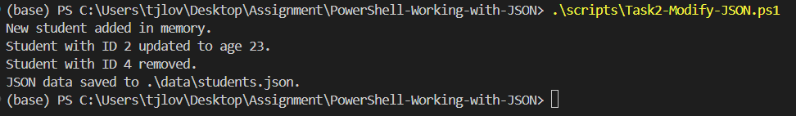
Terminal output showing CSV data saved successfully.

Step 11 — Verify CSV Output
The Task3 script ends with Import-Csv -Path $csvPath | Format-Table. Confirm the output table looks correct.
id name age grade
-- ---- --- -----
1 John Micheal 20 A
2 Jon Mike 23 B
3 Sara Ahmed 19 A
Expected table output.
# Task 3: Export JSON Data to CSV

$jsonPath = ".\data\students.json"
$csvPath = ".\data\students.csv"

# Load JSON data
$jsonData = Get-Content -Path $jsonPath | ConvertFrom-Json

# Convert JSON data to CSV format
$csvData = $jsonData | Select-Object id, name, age, grade

# Export CSV
$csvData | Export-Csv -Path $csvPath -NoTypeInformation

Write-Host "CSV data saved to $csvPath."

# Verify CSV output
Import-Csv -Path $csvPath | Format-Table

Write-Host "CSV verification completed."

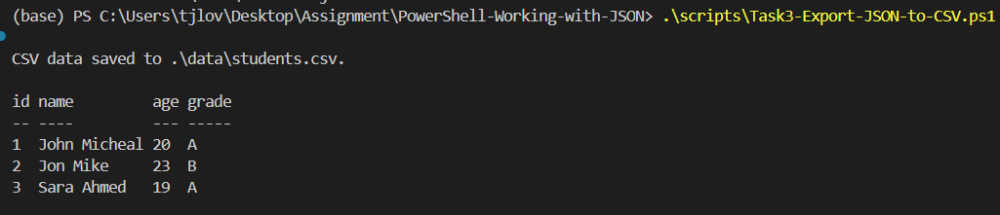
PowerShell output showing columns such as id, name, age, and grade.

Step 12 — Verify Final Files
Open File Explorer at the project root and confirm scripts/ has all 3 .ps1 files, data/ has both students.json and students.csv, and screenshots/ has all your captures.
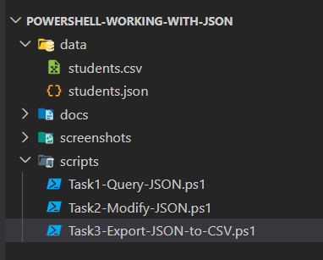
File Explorer showing the final repository folder structure.

.

